Robot v1.30

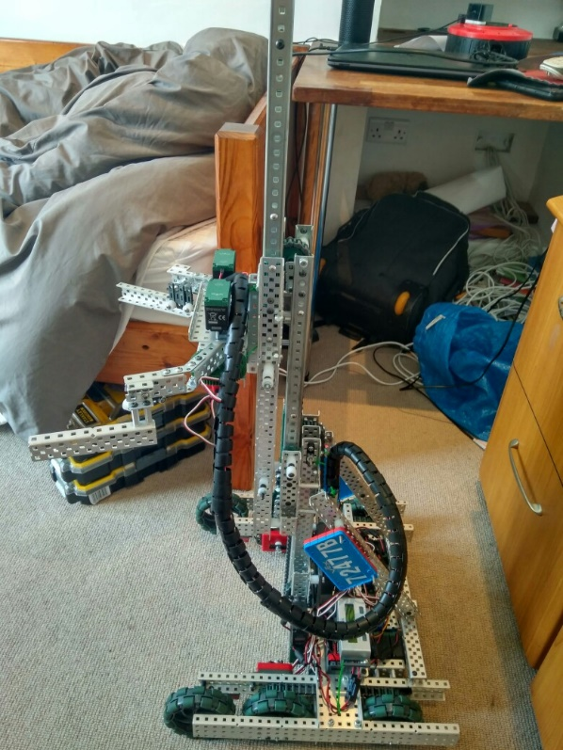

**Specification:**

* 6 Motor HS drive
* 2 drive chains
* 6 wheels
* Aluminium structure
* 4 motor lift
* 3 stage lift
* 2 motor flip down claw
* 5.5kg weight

**Dimensions:**

* 17.5” x 17.5” x 17.5” when not extended

s

Logged by Robbie Buxton

25/08/2017 – 10:09

**Future Changes:**

* Program PID control
* Fix drive problem
* Add limiter switches again

**Overview:**

Over the last 20 days we had a bit of a break from working on the robot as some team members had holidays and it was not possible to organize build sessions. The focus of this update was reworking the rubber band system so we could reliably lift the mobile goal as we were having trouble with it earlier. We moved the primary rubber band system closer together and added a counter rubber band system to hold the robot inside the size limit at the begging of the match. The counter rubber band system is released by moving the robot forward as it is attached to a rotating lock bar on the wheel axle. We also extended the bar used to stop chain skipping under both chains. While adjusting the rubber band systems we also temporary removed the limiter switches. One of the problems with the robot that we noticed is that the drive shorts out quickly when driving. We fiddled with the drive to try and reduce friction but that did not seem to have much effect. We need to fix this quite urgently because it renders the robot nearly useless.

**Changes Made:**

* Reworked rubber band system on the lift
* Added counter rubber band system
* Added rubber band releases
* Minor adjustments inside drive
* The bar used to stop chain skipping has been expanded to both chains
* Temporarily removed limiter switches